User Guide

## Background:

Problem : Type 2 disabetes, it can only be cured by exercise and good diet

-major causes

1. actvity & food

2.environment

3.genetics

4.conditions & medication

5.stress & sleep

Solution : focus on actvity & food, environment

-Motivation is key feature

-provide reason to become healthy and being active

-understand own body condition

-step by step process to lose weight

How : with mobile application

-below are steps for using app

1.test the body condition

2.base on the body condition, app gives appropriate mission to become physically active

3.when patients accompolish the mission, they get points

4.some patients can get stars when they constantly finishing mission well

5.with points and star, patient can get discount

Main goal : Achieve our vision

-vision : increase physical activity, form good habit, reduce health care cost in the future

-mission : motivate patient or user to transform habit

-more people are motivated to transform

First glance : journey to healthy life with this app

-motivation is main feature

-giving courage to user in first glance

## Details:

-Reward system : external motivation tool to help patient forming healthy habit

-user can collect points by accomplishing mission. reward can be selected with points

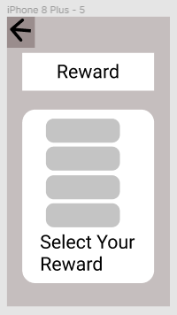

*issue : reward may be change over time

-Health test : deeper understand of own body

-help understand body in number and graphic

-internal motivation by facing seriousness of body condition

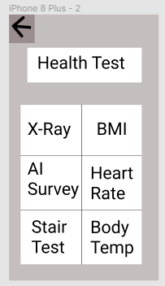

*issue : result may be delay depend on user

-24/7 Q&A : sense of bond and relation formed

-user can ask any questions

-help setting realistic goal

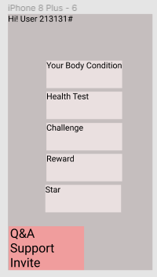

*issue : answer to the Q&A may be delayed